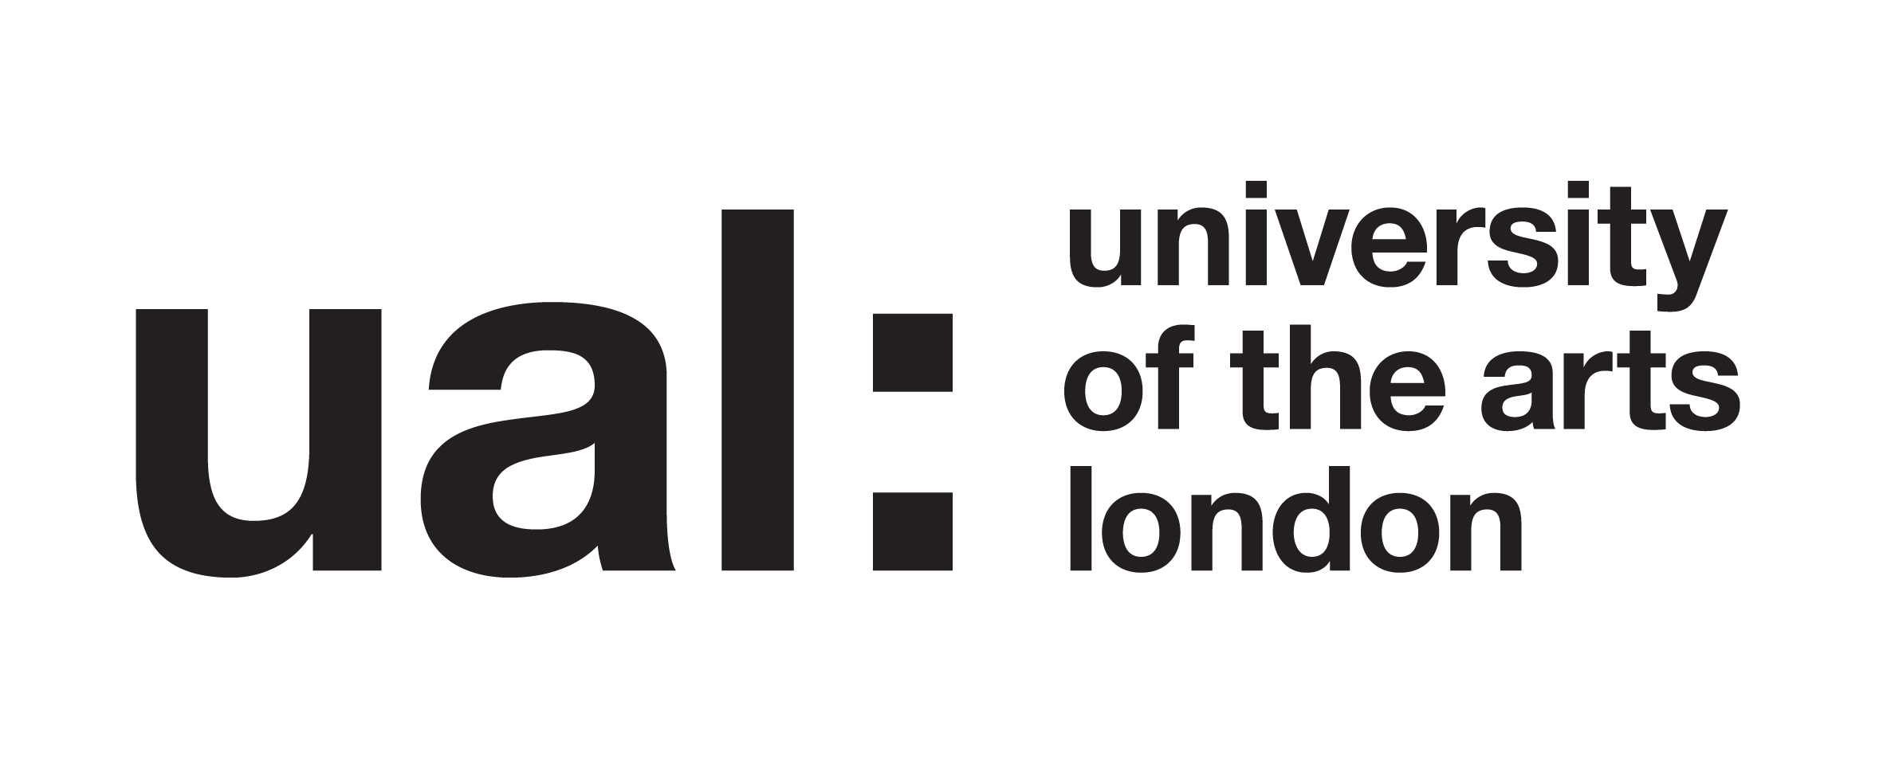

Participant Consent Form

Project Title: Cross-Pollination with Sari workshop

This study is a part of my Pg-Cert Academic Practice at UAL where I am researching how people can incorporate their own cultural heritage into their making processes.

You have been invited to attend a Sari Workshop to help me explore this idea. I may be taking photos, video or audio recordings during the workshop, as data to help me understand how students engage with their work thorough heritage and culture on the MA FDT WW course.

You are being invited to take part in my research project. Before you decide to take part it is important for you to understand why the research is being done and what it will involve. Do ask me if anything is unclear or if you would like more information.

- I understand that I have given my consent for my responses during the Sari Workshop to be recorded.

- I fully give my consent to take part.

- I understand that I have given approval for my opinions to be included in the research outputs. Anything I say may be used in academic presentations or papers relating to the project, although these quotations will be anonymous.

- What is going to happen and why it is being done has been explained to me, and I have had the opportunity to discuss the details and ask questions.

- Having given this consent I understand that I have the right to withdraw from the research at any time without disadvantage to myself and without having to give any reason.

- I hereby fully and freely consent to participation in the study, which has been fully explained to me.

Participant’s name
(BLOCK CAPITALS):
Participant’s signature: |  | Date:
Investigator’s name  (BLOCK CAPITALS): | Navinbhai Patel
Investigator’s signature: |  | Date:

Contact
Investigator: Navinbhai Patel
Email n.r.patel@arts.ac.uk

